Information about the inernals of the PC14xx Sharp PC family

Compiled from several sources

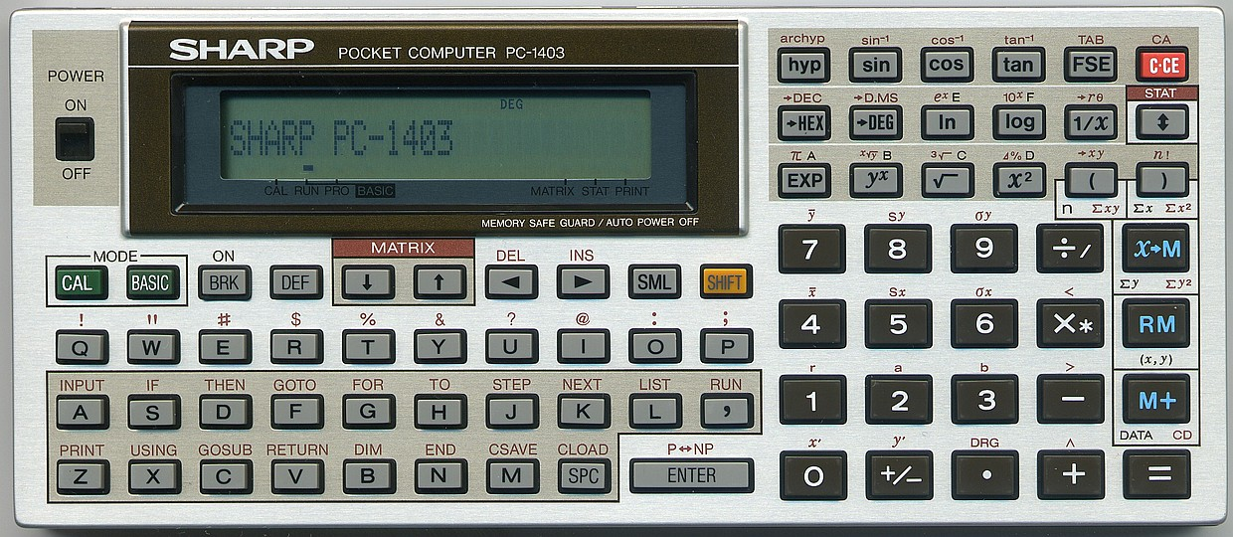

The LCD Screen
Character location in memory:
1-6 | 12288 (&3000) - 12317
7-9 | 12333 - 12347
10-12 | 12318 - 12332
13-15 | 12396 (&306C) - 12382
16-18 | 12411 - 12397
19-24 | 12381 - 12352

LCD Display memory map
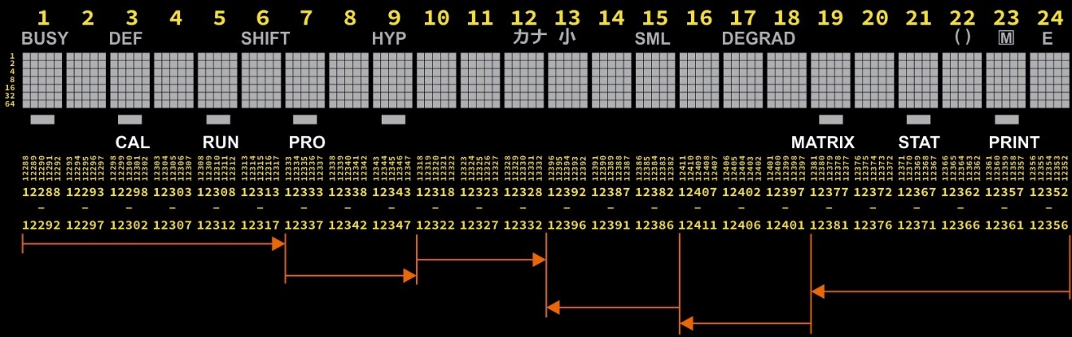

Display flags
12348 | 001 カナ kana (Katakana)  002 ⼩ klein (Kanji)  004 SML  008 ▃ STAT  016 ▃ MATRIX  032 ▃ (rechts von PRO)  064 ▃ (links von CAL) | 12349 | 001 BUSY  002 DEF  004 SHIFT  008 HYP  016 ▃ PRO  032 ▃ RUN  064 ▃ CAL | 12412 | 001 E  002 M  004 ( )  008 RAD  016 G  032 DE  064 ▃ PRINT

Example of calculating the value of a display column:

Display flag bits
12348 | 12349 | 12412
1 | lf (weird chars) | BUSY | E
2 | m (weird chars) | DEF | M
4 | SML | SHIFT | ()
8 | STAT | HYP | RAD
16 | MATRIX | PRO | G
32 | BASIC | RUN | DE
64 | Block | CAL | PRINT

PC-1403 ROM routines
04B4 - to turn the LCD off:
CALL &04B4
04B8 - to turn the LCD on:
CALL &04B8
Note how the LCD on/off is controlled by bit-0 of the CPU C-port, which includes other control bits.
Below the 04B4 and 04B8 disassembly:
LIA 0 ; LCD_OFF
JRP SET_C
LIA 1 ; LCD_ON
SET_C: LIP 5F ; OutC Port
EXAM
OUTC
RTN
4587 (ROM bank #9) - Display an ASCII string.
The string is assumed to be stored at locations starting at 0x10 (internal CPU RAM; see below) for max 24 char and terminated by a 0. Note how no boundary safety is present, so a crash could happen is the string is not terminated within the 24 characters.
A ROM-bank switch to bank #9 is needed, to access the routine.
Entry with J = 1.
Below an example code fragment using the 4587 routine:
LIJ 1
LIDP 0x3C00 ; Read current memory bank#
LDD
PUSH ; save it to stack
LIA 0x09 ; select External ROM bank #9
STD
CALL 0x4587 ; PC-1403 ROM entry point for the print
POP ; Restore original bank#
LIDP 0x3C00 ; bankswitch
STD ; and set it
4CED (ROM bank #9) – move PRINT buffer to internal RAM
Clear internal RAM at 0x10 and transfer here 24 characters from FD60 (print buffer, possibly used by BASIC too).
Content of FF6C/FF6D should prepared with the pointer to string end.
Entry with J = 1.
A ROM-bank switch to bank #9 is needed, to access the routine.

BASIC program memory
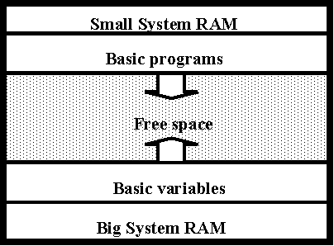
- The program memory starts at 32768 and ends at 65535. The rest belongs to the system like display, interfaces and main program!
- The first BASIC line starts at 32817 (&8031). You can move this position and move it back to have space for data. The memory locations 65281 (&FF01) and 65282 (&FF02) define this position:
PEEK 65281+256* PEEK 65282 = start address.
On a fresh PC-1403 (8K RAM model; not ‘H’): 48 + 224*256 = 57392 = $E030
- At this address there must be a byte with the value 255. After this, the first line starts.
- The end of the BASIC program is marked with a 255, too. This address is given in the pointer at 65283 and 65284. Address of this end position = PEEK 65283+ 256* PEEK 65284
In order to create room for custom assembler program, or data, POKE the new BASIC start address in 65281 (&FF01) and 65282 (&FF02) and then reset program area with a NEW command.
E.g. Reserving 2Kb (2048 bytes) on top of the program area (PC-1403):
NEW
MEM
> 6878
POKE &FF01, 48, (224 + 2048/256)
NEW
MEM
> 4830

Handwritten notes by HrastProgrammer:
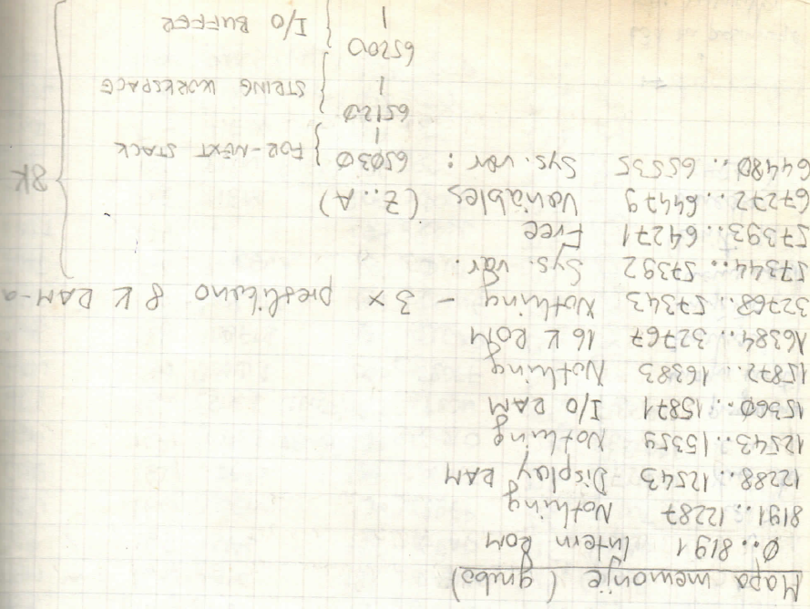

Some memory pointers
&0000  -  &1FFF | 0  -  8191 | Internes ROM
&E030 | 57392 | Beginn Basic (standard)
&FB10  -  &FBDF | 64272  -  64479 | Standardvariable
&3000  -  &301D | 12288  -  12317 | Display Stellen 1-6
&301E  -  &302C | 12318  -  12332 | Display Stellen 10-12
&302D  -  &303B | 12333  -  12347 | Display Stellen 7-9
&3040  -  &305D | 12352  -  12381 | Display Stellen 24-19
&305E  -  &306C | 12382  -  12396 | Display Stellen 15-13
&306D  -  &307B | 12397  -  12411 | Display Stellen 18-16
&303C | 12348 | Display Statusanzeigen
&303D | 12349 | Display Statusanzeigen
&307C | 12412 | Display Statusanzeigen
&FF09  -  &FF10 | 65289  -  65296 | Passwort
&FF47  -  &FF48 | 65351  -  65352 | LoByte  WAIT Intervall  HiByte

Address Range (Hex) | Description | Translation/Notes
12348, 12349, 12412 | DISPLAY INDICATORS | Memory addresses for display status indicators
12440 - 12447 | SEED FOR RND | Random number generator seed location
57350 - 57391 | Copy to ibew space | Copies to memory area (65280 - 65321)
64576 - 64587 | Storing result of det X→x operation | Saves operation results
64592 - 64767 | Most likely for disk operations | 176 bytes free
64864 - 64887 | Text displayed on screen | At a specific screen position
65120 - 65199 | STRING WORKSPACE | Memory area for string operations
65200 - 65279 | INPUT BUFFER | Buffer for user input
65289 - 65296 | PASS STRING | (65289) = 245 (8F5)
65326, 65327 | Variable address | Address of variable last used in mode/ADET... (-1)
65488 - 65519 | Copy notespage enabling | 32 bytes free
65512 - 65519 | CALCULATOR MEMORY | Memory area for calculations
65520 - 65527 | LAST CALCULATOR | Previous calculation storage
65528 - 65535 | ANSWER | Special place for result decimal point
65287 – 65288 | Begin of arrays’ area

BASIC command tokens
Codetabelle
 | &8x | &9x | &Ax | &Bx | &Cx | &Dx | &Ex
&x0 | MDF | FACT | RND | RUN | RANDOM | TO | GOSUB
&x1 | REC | LN | AND | NEW | DEGREE | STEP | AREAD
&x2 | POL | LOG | OR | CONT | RADIAN | THEN | LPRINT
&x3 | ROT | EXP | NOT | PASS | GRAD | ON | RETURN
&x4 | DECI | SQR | ASC | LIST | BEEP | IF | RESTORE
&x5 | HEX | SIN | VAL | LLIST | WAIT | FOR | CHAIN
&x6 | TEN | COS | LEN | CSAVE | GOTO | LET
&x7 | RCP | TAN | PEEK | CLOAD | TRON | REM
&x8 | SQU | INT | CHR$ | MERGE | TROFF | END
&x9 | CUR | ABS | STR$ |  | CLEAR | NEXT
&xA | HSN | SGN | MID$ |  | USING | STOP
&xB | HCS | DEG | LEFT$ | OPEN | DIM | READ
&xC | HTN | DMS | RIGHT$ | CLOSE | CALL | DATA
&xD | AHS | ASN | INKEY$ | SAVE | POKE | PAUSE
&xE | AHC | ACS | PI | LOAD |  | PRINT
&xF | AHT | ATN | MEM |  |  | INPUT | &EF,xx

Extended (2-bytes &EF,xx) BASIC command tokens
&EF,xx
 | &EF,&8x | &EF,&Ax | &EF,&Bx | &EF,&Ex
&EF,&x0 | EOF |  | FILES | OUTPUT
&EF,&x1 | DSKF | XOR | LFILES | APPEND
&EF,&x2 | LOF |  | INIT | AS
&EF,&x3 | LOC |  | KILL
&EF,&x4 |  |  | NAME
&EF,&x5 |  |  | SET
&EF,&x6 |  |  | COPY
&EF,&x8 |  | RENUM
&EF,&x9 |  | DELETE

Standard variable locations
Numerisch |  | Text |  | Hex | Dez
A | A(1) | A$ | A$(1) | &FBD8 - &FBDF | 64472 - 64479
B | A(2) | B$ | A$(2) | &FBD0 - &FBD7 | 64464 - 64471
C | A(3) | C$ | A$(3) | &FBC8 - &FBCF | 64456 - 64463
D | A(4) | D$ | A$(4) | &FBC0 - &FBC7 | 64448 - 64455
E | A(5) | E$ | A$(5) | &FBB8 - &FBBF | 64440 - 64447
F | A(6) | F$ | A$(6) | &FBB0 - &FBB7 | 64432 - 64439
G | A(7) | G$ | A$(7) | &FBA8 - &FBAF | 64424 - 64431
H | A(8) | H$ | A$(8) | &FBA0 - &FBA7 | 64416 - 64423
I | A(9) | I$ | A$(9) | &FB98 - &FB9F | 64408 - 64415
J | A(10) | J$ | A$(10) | &FB90 - &FB97 | 64400 - 64407
K | A(11) | K$ | A$(11) | &FB88 - &FB8F | 64392 - 64399
L | A(12) | L$ | A$(12) | &FB80 - &FB87 | 64384 - 64391
M | A(13) | M$ | A$(13) | &FB78 - &FB7F | 64376 - 64383
N | A(14) | N$ | A$(14) | &FB70 - &FB77 | 64368 - 64375
O | A(15) | O$ | A$(15) | &FB68 - &FB6F | 64360 - 64367
P | A(16) | P$ | A$(16) | &FB60 - &FB67 | 64352 - 64359
Q | A(17) | Q$ | A$(17) | &FB58 - &FB5F | 64344 - 64351
R | A(18) | R$ | A$(18) | &FB50 - &FB57 | 64336 - 64343
S | A(19) | S$ | A$(19) | &FB48 - &FB4F | 64328 - 64335
T | A(20) | T$ | A$(20) | &FB40 - &FB47 | 64320 - 64327
U | A(21) | U$ | A$(21) | &FB38 - &FB3F | 64312 - 64319
V | A(22) | V$ | A$(22) | &FB30 - &FB37 | 64304 - 64311
W | A(23) | W$ | A$(23) | &FB28 - &FB2F | 64296 - 64303
X | A(24) | X$ | A$(24) | &FB20 - &FB27 | 64288 - 64295
Y | A(25) | Y$ | A$(25) | &FB18 - &FB1F | 64280 - 64287
Z | A(26) | Z$ | A$(26) | &FB10 - &FB17 | 64272 - 64279

Keyboard
The PC1403(H) keyboard is scanned using the IA port and the external K port, having the following layout:
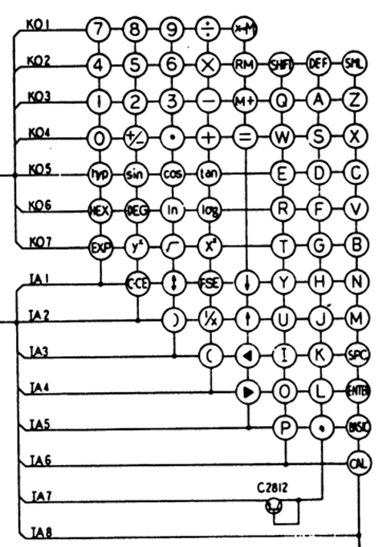
Here’s a fragment from the ROM routine scanning the IA port, as an example:
LIP 5C ; IA port address
LIA 01 ; initial strobe mask
EXAM
OUTA ; strobe on IA1
LIDP 3E00
ANID 00 ; clear K-port strobe
WAIT 25
LDM ; IA port -> A
RC
SL
EXAM ; A -> IA
LP 0A
INA ; get a key (if any)
Note how the IA is bi-directional, used both for output to set the strobe signals, and input to get the pressed key (if any), while the K-port is for output only, to set strobes only.

PC 1403 ROM routines
1494 - Wait for a keystroke.
Returns with keycode (see below) in A registry:
CALL &1494
0E68 - Scan the keyboard (non-blocking)
Returns with keycode (see below) in A registry. 0xFF if none has been pressed.
Carry flag set if BRK pressed:
CALL &0E68
NOTE – I haven’t figured out yet why calling repeatedly &0E68 in a loop seems like spinning the CPU too much, apparently drawing current and dimming the LCD, while a call to &1494 (while still using the 0E68 inside) keeps the LCD display on and clear, at the same time being responsive enough to key strokes.

Key codes
List of keycodes returned by 1494 or 0E68 routines:
// SHARP POCKET COMPUTER PC-1403H 32KB +---+ +---+ +---+ +---+ +---+ +---+
// |hyp| |sin| |cos| |tan| |FSE| |CCE|
// on +---+ +---+ +---+ +---+ +---+ +---+
// +-+ +----------------------------------------------------+ 67 66 65 64 4 6
// ¦ ¦ ¦ DEG | +---+ +---+ +---+ +---+ +---+ +---+
// +-+ ¦ > | |HEX| |DEG| | ln| |log| |1/x| | ^ |
// off ¦ _ | +---+ +---+ +---+ +---+ +---+ +---+
// +----------------------------------------------------+ 75 74 73 72 11 5
// CAL RUN PRO +---+ +---+ +---+ +---+ +---+ +---+
// |EXP| |y^x| | v~| |x^2| | ( | | ) |
// +---+ +---+ +---+ +---+ +---+ +---+
// 83 82 81 80 17 12
// +---+ +---+ +---+ +---+ +---+ +---+ +---+ +---+ +---+ +---+ +---+ +---+ +---+ +---+ +---+
// |CAL| |BAS| |BRK| |DEF| | v | | ^ | | < | | > | |SML| |SHI| | 7 | | 8 | | 9 | | / | |X>M|
// +---+ +---+ +---+ +---+ +---+ +---+ +---+ +---+ +---+ +---+ +---+ +---+ +---+ +---+ +---+
// 25 22 - 37 3 10 16 21 36 38 35 34 33 32 31
// +---+ +---+ +---+ +---+ +---+ +---+ +---+ +---+ +---+ +---+ +---+ +---+ +---+ +---+ +---+
// | Q | | W | | E | | R | | T | | Y | | U | | I | | O | | P | | 4 | | 5 | | 6 | | * | | RM|
// +---+ +---+ +---+ +---+ +---+ +---+ +---+ +---+ +---+ +---+ +---+ +---+ +---+ +---+ +---+
// 46 54 62 70 78 2 9 15 20 24 43 42 41 40 39
// +---+ +---+ +---+ +---+ +---+ +---+ +---+ +---+ +---+ +---+ +---+ +---+ +---+ +---+ +---+
// | A | | S | | D | | F | | G | | H | | J | | K | | L | | , | | 1 | | 2 | | 3 | | - | | M+|
// +---+ +---+ +---+ +---+ +---+ +---+ +---+ +---+ +---+ +---+ +---+ +---+ +---+ +---+ +---+
// 45 53 61 69 77 1 8 14 19 23 51 50 49 48 47
// +---+ +---+ +---+ +---+ +---+ +---+ +---+ +---+ +---------+ +---+ +---+ +---+ +---+ +---+
// | Z | | X | | C | | V | | B | | N | | M | |SPC| | ENTER | | 0 | |+/-| | . | | + | | = |
// +---+ +---+ +---+ +---+ +---+ +---+ +---+ +---+ +---------+ +---+ +---+ +---+ +---+ +---+
// 44 52 60 68 76 0 7 13 18 59 58 57 56 55

ROM Routines for other PC models (different from 1403(H))
(excerpt from “das_grosse_pocket_computer_buch-compressed.pdf”; addresses in decimal)
GETKEY
PC 140X: 5208 PC 1421: 5153
PC 126X: 4414 PC 1350: 4618
Function:
Waits until a key is pressed, then returns with the key code in A and 24634 (PC 126X: 26156, PC 1350: 28503)
Notes:
The SHIFT key assignments are also taken into account. If the OFF switch is pressed, the routine returns with A=10. No automatic shutdown of the computer if no key is pressed. The keys X+>M, RM, M+, +/-, F<->E are not recognized on the PC 14XX.
When calling the program in RUN mode, the program will be terminated with ERROR 4 if the key combination 'DEF letter key' is pressed.
INKEY
PC-140X: 3387 PC-1421: 3359
PC-126X: 2729 PC-1350: 3003
Function:
If a key is pressed, the code of this key is stored in memory cell Y+1 of the external RAM. So first load the Y register with a suitable address. When you then call the program INKEY and a key is pressed, the code of this key is stored in memory cell Y+1 with the command IYS.

The SC-61860 CPU

Block diagram
(as from PC-1250 service manual)
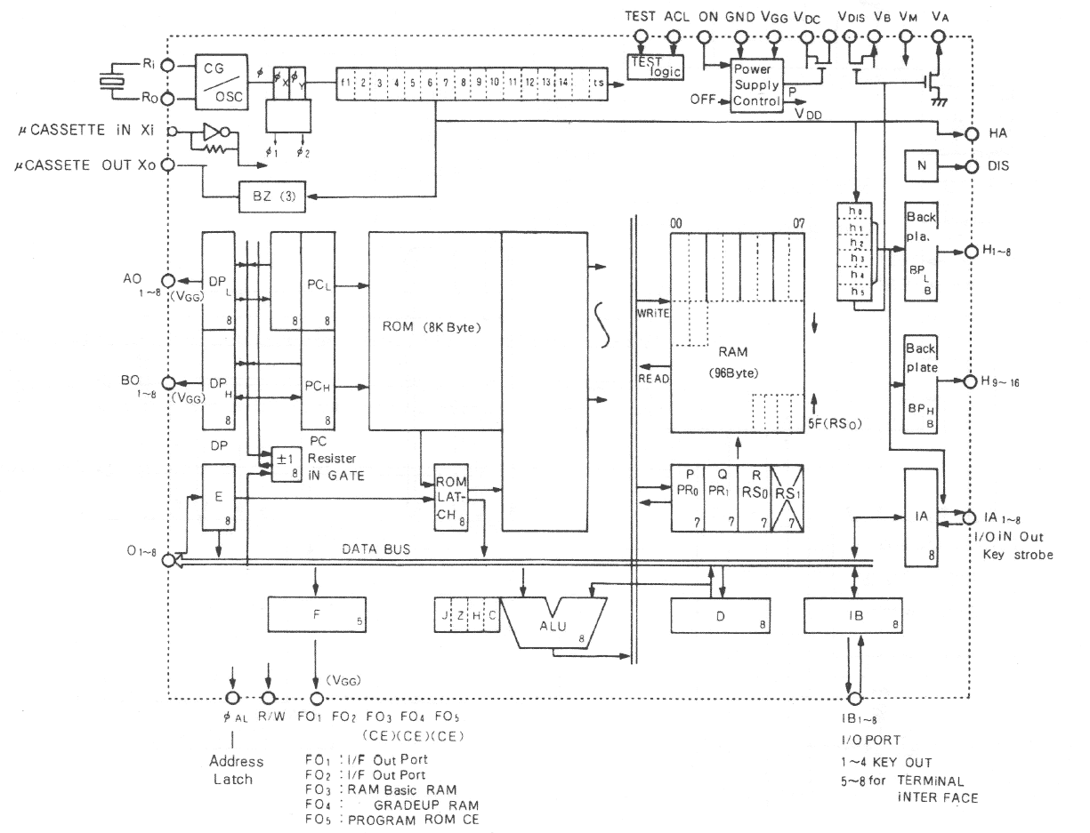

Mnemonics
 | 0x | 1x |  | 2x | 3x | 4x | 5x | 6x | 7x | 8x-Bx | Cx | Dx | Ex-Fx
x0 | LII n | LIDP nm |  | LDP | STP | INCI | INCP | ANIM n | ADIM n | LP l | INCJ | SC | CAL ln
x1 | LIJ n | LIDL n |  | LDQ | STQ | DECI | DECP | ORIM n | SBIM n |  | DECJ | RC
x2 | LIA n | LIP n |  | LDR | STR | INCA | STD | TSIM n | RZ n |  | INCB | SR
x3 | LIB n | LIQ n |  | CLRA | NOPT | DECA | MVDM | CPIM n | RZ n |  | DECB | NOPW
x4 | IX | ADB |  | IXL | PUSH | ADM | MVMP | ANIA n | ADIA n |  | ADCM | ANID n
x5 | DX | SBB |  | DXL | MVWP | SBM | MVMD | ORIA n | SBIA n |  | SBCM | ORID n
x6 | IY |  |  | IYS |  | ANMA | LDPC | TSIA n | RZ n |  | TSMA | TSID n
x7 | DY |  |  | DYS | RTN | ORMA | LDD | CPIA n | RZ n |  | CPMA | SZ n
x8 | MVW | MVWD |  | JRNZP n | JRZP n | INCK | SWP | NOPT | CALL nm |  | INCL | LEAVE
x9 | EXW | EXWD |  | JRNZM n | JRZM n | DECK | LDM | CASE | JP nm |  | DECL | NOPW
xA | MVB | MVBD |  | JRNCP n | JRCP n | INCM | SL | NOPT | SET knm |  | INCN | EXAB
xB | EXB | EXBD |  | JRNCM n | JRCM n | DECM | POP | TEST n |  |  | DECN | EXAM
xC | ADN | SRW |  | JRP n |  | INA |  |  | JPNZ nm |  | INB
xD | SBN | SLW |  | JRM n |  | NOPW | OUTA |  | JPNC nm |  | NOPW | OUTB
xE | ADW | FILM |  |  |  | WAIT n |  |  | JPZ nm |  | NOPT
xF | SBW | FILD |  | LOOP n |  | IPXL | OUTF | IPXH | JPC nm |  |  | OUTC
k,n,m = 00-FF
l = 00-3F
ln = 0000-1FFF

Register RAM
00 | I
01 | J
02 | A
03 | B
04 | XL
05 | XH
06 | YL
07 | YH
08 | K
09 | L
0A | M
0B | N
0C
…
10 | X float
…
17
18 | Y float
…
1F
… | …
. . . | Stack
5B
5C | IA
5D | IB
5E | FO
5F | Cout

The floating point representation
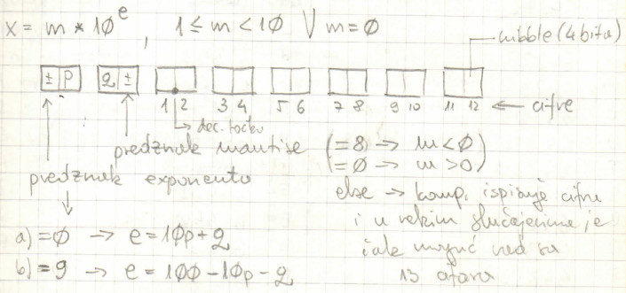
(image above: credit HrastProgrammer’s notes)
From the PC 1350 Machine Language manual:
The internal representation of the floating point, used in BASIC variables too, is made of 8 bytes: a numeric value consists of an exponent, a mantissa sign, and a mantissa. 2 of them for the exponent, including sign, and 6 for the mantissa, in BCD format (i.e. a 4-bit nibble for each 0-9 digit).
Numbers from -9.999999999 x 10⁹⁹ to 9.999999999 x 10⁹⁹ can be represented.
Exponent
The exponent is represented using two decimal digits.
The most significant digit is always zero for positive numbers.
Negative exponents are represented using a complement: 901 (10⁻⁹⁹) to 099 (10⁹⁹):
Mantissa sign
Zero (0) is used when the mantissa is positive.
Eight (8) is used when the mantissa is negative.
Example numbers stored at BASIC variable ‘B’ location:
6CF0H 6CF7H
00H | 30H | 15H | 00H | 00H | 00H | 00H | 00H | 1500
00H | 00H | 12H | 34H | 56H | 00H | 00H | 00H | 1.23456
99H | 70H | 12H | 34H | 56H | 78H | 90H | 00H | 0.00123456789
00H | 88H | 12H | 34H | 00H | 00H | 00H | 00H | -1.234x10⁸

PC-1403 (H) ROM math routines

Math on register RAM
(credit: HrastProgrammer)
Some of the math routines (hex addresses) in internal ROM (default ROM bank #0), referring to X-Float (0x10..0x17) and Y-float (0x18..0x1F) in the CPU register memory area:
0143 | Zero moved to floatY | 0 -> floatY
0149 | Zero moved to floatX | 0 -> floatX
0169 | 1 to floatY | 1 -> floatY
10BE | Add | floatX + floatY -> floatX
10D3 | Subtract | floatX – floatY -> floatX
10DF | Multiply | floatX * floatY -> floatX
10E8 | Divide | floatX / floatY -> floatX
1446 | Unsigned 16-bit binary to Float | (19H lsb, 18H msb) -> floatX
144D | Signed 16-bit binary to Float | (19H lsb, 18H msb) -> floatX
1609 | Float to Signed 16-bit binary | floatX -> (19H lsb, 18H msb)
0398 | 16-bit BA moved to Y | B:A -> floatY
039D | 16-bit BA moved to X | B:A -> floatX
...
Many more are listed in the handwritten notes by HrastProgrammer, a Slovenian guy who made a hard work reverse-engineering parts of the PC-1403 ROM (back then when no sophisticated debugging tools were available), and who shared them with me some time ago, but they’re hard to decypher… Will add more, as soon as I get to understand them.

Matrix operations
(credit: HrastProgrammer)
Matrix operations are normally used in PC-1403 while in ‘CAL’ mode. There’s a way to make use of them in BASIC programs too.
The following are the ROM routines (hex addresses) operating on matrices stored as X, Y, and M BASIC matrix variables:
65FD | X + Y → X
65F7 | X – Y → X
65F7 | X * Y → X
65FC | X * inv Y → X
6604 | inv X → X
660C | x + X → X
6614 | x – X → x
6619 | x * X → X
661E | x * (inv X) → X
6623 | X ←→ Y
662B | trn X → X
6630 | det X → x
6635 | -X → X
663A | sgn X → X
663F | X → M
6647 | M → X
664C | X + M → X
X, Y and M are matrices (DIMensioned 2-dimensional BASIC arrays), while x (lower case here) is the simple BASIC variable X.
For example, suppose that you want to solve the following system of linear equations from the PC-1403 users manual (page 77):
2x + 5y - z = -1
x - y + 4z = 12
3x + 2y + z = 9
The following program can do this (completes in about 2 seconds):
5 "A": CLEAR: RESTORE 20
10 DIM X(2,2): FOR I=0 TO 2: FOR J=0 TO 2: READ X(I,J): NEXT J: NEXT I
20 DATA 2,5,-1,1,-1,4,3,2,1
30 DIM Y(2,0): FOR I=0 TO 2: READ Y(I,0): NEXT I
40 DATA -1,12,9
50 CALL &6604: REM invX->X
60 CALL &65F7: REM X*Y->X
70 FOR I=0 TO 2: PRINT X(I,0): NEXT I
NOTE (as per PC-1403 Manual, page 44):
... matrixes X, Y, and M are stored in the same memory area as BASIC arrays X(*,*), Y(*.*), and M(*.*).
In other words, the values of the matrix elements entered in the BASIC mode can be calculated in the CAL mode.
When entering the values of matrix elements in the BASIC mode, pay attention to the following points:
(1) Matrix elements X(i, k) correspond to BASIC array elements X(i-1, k-1).
For example, X(1, 2) correspond to array X(0, 1).
(2) All the matrix element values stored in memory will be cleared by BASIC command RUN, CLEAR, or NEW.

The 11-pin connector
Pinout:
pin | Function
1 (TOP) | MTout2
2 | VCC
3 | GND
4 | BUSY
5 | Dout
6 | Xin (MTin)
7 | Xout (MTout1)
8 | Din
9 | ACK
10 | I01
11 | I02

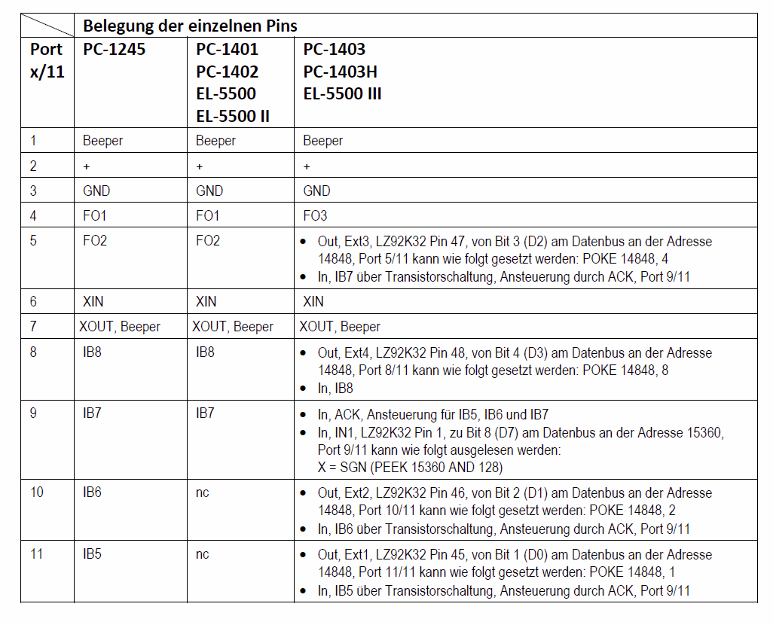
This is the internals schematics:
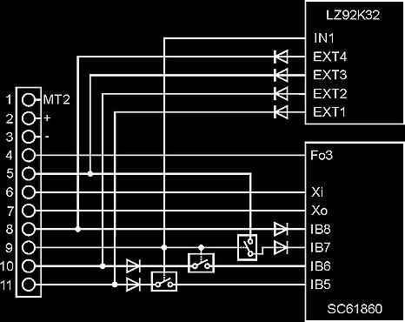

Using the PC-1403, output control works as follows.
The Pins 5,8,10,11 are connected to the external Ports 1-4 (Chip LZ92K32) for data output.
POKE 14848,1 sets Ext1 (Pin 11) to HIGH
POKE 14848,2 sets Ext2 (Pin 10) to HIGH
POKE 14848,4 sets Ext3 (Pin 5) to HIGH
POKE 14848,8 sets Ext4 (Pin 8) to HIGH
in machine language it’s the following code:
LIDP 14848
LIA x
STD
RTN
(16,58,0,2,x,82,55)
Xout, pin 7, also connected to the internal beeper and used for data-cassette writing, is controlled by the ‘Cout’ port on bit #4 (counting from 0), set with ‘AND 0x10’ for example with a machine program like below:
12 5F LIP 0x5F ; 0x5F --> P
61 10 ORIM 0x10 ; (P) | 0x10 --> (P)
DF OUTC ; (0x5F) --> Port C
or reset with:
12 5F LIP 0x5F ; 0x5F --> P
60 10 ANIM 0x00 ; (P) & 0x00 --> (P)
DF OUTC ; (0x5F) --> Port C

CE 140 F (Disk drive)
(Excerpts from the CE-140 Service Manual)
DATA TRANSFER
o Data transmit protocol (pocket computer to FDD)
The pocket computer sets low order four bits of one byte data on DIN, DOUT, I02 and I01. Then, BUSY is forced high. On the FDD side, ACK is forced low after confirming a low state of BUSY to finish the first handshaking. As the second handshaking is done in the same manner, transfer of one byte data is completed.
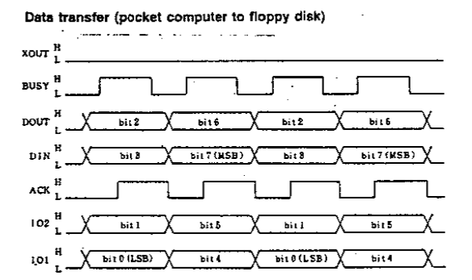
o Data receive protocol (FDD to pocket computer)
If ACK is high for the FDD is in process, ACK is set low for more than 10ms before data are transferred from the FDD after completion of its processing.
The FDD set ACK high after setting data on DIN, DOUT, IO2 and IO1. However, the data must be sent out in 50ms after ACK turned low.
After recognizing a high state of ACK, the pocket computer receives a 4-bit data, then BUSY is set low. After the FDD confirms a high state of BUSY, ACK is set low. After the pocket computer confirms a low state of ACK, BUSY is forced low to terminate the first handshaking. A single byte data is received by repeating this procedure.
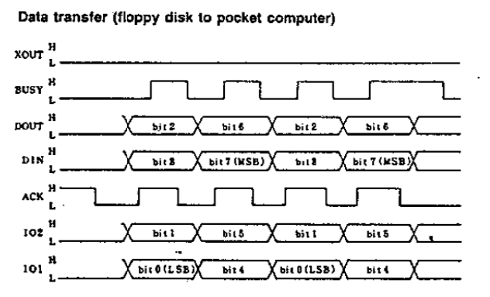

PC-1403 Schematics
